# The Rosary Catholic Primary School

## CATHOLIC LIFE AND MISSION

## POLICY

**Based on the values and principles of the UN Convention on the Rights of the Child.**

**2024 - 2025**

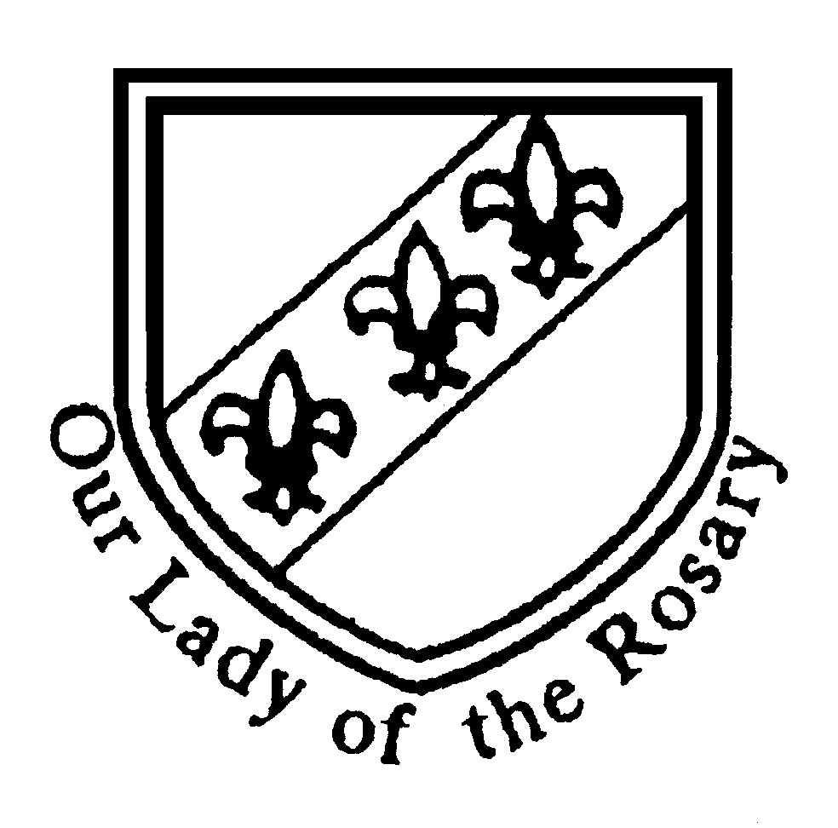

“Jesus Christ, son of Mary, Son of God, is the centre of the Rosary community where we live, love and learn together”

“Jesus Christ, son of Mary, Son of God, is the centre of the Rosary community where we live, love and learn together”

RRSA - Article 14

You have the right to choose your own religion

and beliefs. Your parents should help you decide what is right and wrong, and what is best for you.

Article 30

You have the right to practice your own culture, language and religion - or any you choose. Minority and indigenous groups need special

protection of this right.

**Policy for Catholic Life and mission**

At the Rosary Catholic Primary School, the whole life of being a Catholic School is an expression through the practice of Catholic belief and Catholic tradition. As the pupils grow, they will be encouraged to put their faith into practice in their own lives through the Catholic Virtues: grateful and generous, attentive and discerning, compassionate and loving, faith-filled and hopeful, eloquent and truthful, learned and wise, curious and active and intentional and prophetic. This is what our children are growing to be. Not only are these virtues taught through teaching, but also in the daily practice of the faith as our children will be helped by the personal example of the staff to act out these virtues.

**The Aims of Catholic Life and mission**

We believe that Catholic Life in our school aims to provide opportunity for all pupils and staff:

* To establish, maintain and develop a Catholic ethos which is permeated in everything we do and is apparent to all those who enter the school.
* To provide frequent opportunities for conscious and active participation in collective worship through Holy Mass and other services/celebrations in accordance with the rites of the Catholic Church to all in the community.
* To provide a supportive Sacramental Programme in collaboration with the Parish in accordance with the rites of the Catholic Church and diocesan policy.
* To create a place of learning where Gospel values and the teachings of the Catholic Church are evident in everything we do.
* To model the image of Christ in the way we lead and manage the school.
* To provide an enriched curriculum which is creative, inspiring and inclusive for all pupils which is fundamentally based on the teachings of Jesus and his Holy Church.
* To develop the prayer and spiritual life of all members of our school and the community it serves.
* To be an outreaching centre of God’s mission on earth in promoting the virtues of faith, hope and charity.
* To cultivate the culture of vocation by educating pupils to be active in their faith and by reaching out to those in our community and beyond.

**Pastoral, Spiritual, Moral, Social, Vocational and Cultural needs**

We endeavour to meet the pastoral, spiritual, moral and social needs of the children by:

* Providing good Catholic role models for the younger citizens of the future so that they may follow in Jesus’ footsteps.
* Maintaining, working with and developing successful links with the home, parish, archdiocese, community and the wider world.
* Completing curriculum activities where possible to encourage and celebrate the multi-cultural nature of the school e.g. Black History Month, Chinese New Year, Refugee Week, Eid and Multicultural celebrations over a two week period.
* Providing a Vocations Week for pupils to explore their own vocation now and when they are older.
* Children are encouraged and helped to discover the many different ways in which to pray, formal and informal, private and communal. We aim to teach and develop a variety of prayer methods to the children such as: meditating and reflecting in silence whilst being inspired by liturgical music and religious art, pupil prayer, prayer garden, hymns and teaching the Bible.

It is our hope that by working towards the above we play our part in the mission of Christ and his Holy Church on Earth.

**Charitable Outreach**

We at the Rosary Catholic Primary School aim to bring about an awareness of the needs of others.

* During the autumn term, pupils and the community are encouraged to bring in food for those less fortunate during the Harvest Festival celebrations. The food is taken to a local charity such as St Chad’s Sanctuary or Fireside by members of the Faith Council as part of the school’s mission for the poor. This is linked to our work centred on the Season of Creation where we consider our stewardship of God’s creation and the importance of this for harvests around the world.
* During the seasons of Lent we raise funds for various charities at home and overseas, e.g. Father Hudson Homes and CAFOD. Children are always encouraged to help each other as well as their parents, teachers and other people in our community.

As a school we support children in understanding their responsibility towards others and encourage their leadership of charitable outreach. As such each year the children request and organise their own charitable outreach, responding to the needs of the local, national and international community. It is our aim that our whole school ethos is one that will foster and nurture a generous giving of self, an appreciation and respect for one’s own property and that of others.

**Monitoring and Evaluation**

The school has a systematic and planned programme of monitoring for Catholic Life and Mission and have developed our pupils and in particular our Faith Council to work with leaders to evaluate Catholic Life and mission and plan improvements. The Faith Council produce a report for governors as part of this programme of self-evaluation.

**Policy Monitoring and Review**

This policy is monitored by the Subject Leader for Catholic Life and is to be evaluated and reviewed by the whole school staff and governors every year.